Brick Breaker Game user guide

Thank you for taking the time to try the game ☺. The game is really simple and funny and we are going to explain the rules of the game and how to play it.

After installing the game on your android device, launch it. This is the main screen of the game.

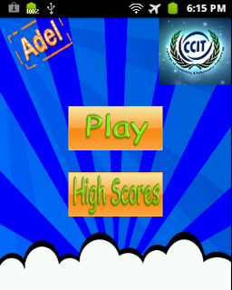

As you've noticed, there are two options, whether to start playing or check the current high scores. First we will check the high scores, press on high scores button.  
Here is an image of how the High Scores menu looks like.

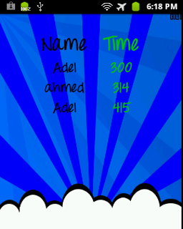

Now, press back button on your device to return back to the main menu.



To start a new game, press play.

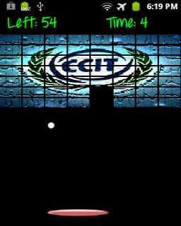

Here I'm going to explain how to play this game. In fact it's really simple; all you have to do is to move the paddle with your finger; so put your finger on the paddle and move it on the right direction or on the left direction. Just make sure that the ball never goes beyond it or you will lose ☹.

Just like this:

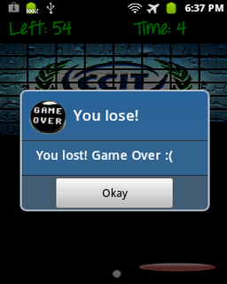

So, always make sure that the ball hits the paddle, and keep breaking the bricks till the last one; when there is no more bricks left you win!

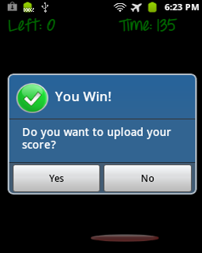

A dialog will popup asking you if you want to upload your score like the one in the previous image. If you press one you will get another dialog with a text input to type your name.

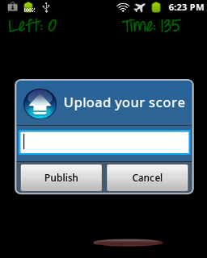

Type your name and then press 'Publish'.

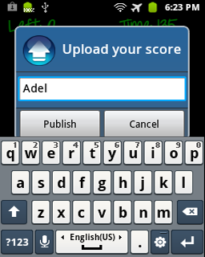

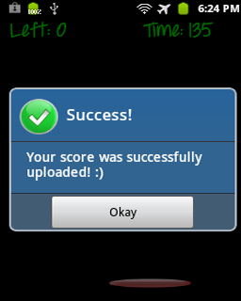

Congratulations! You've successfully uploaded your score. (PS: your score is the time you took to destroy all the bricks; the highest scorer is the one with the least time)